*REVIEW OF CORONAVIRUS nCov-19*

*Pandemic 2020*

*Review of the Novel Coronavirus-2019*

*Table of Contents*

*Review of the Novel Coronavirus-2019* 0

***Editor’s Note:*** 3

***Basics about Viruses:*** 7

*Classification of viruses based on Genomic Material:* 8

**What is a mutation?** 11

**How is Immunity produced?** 13

***Coronavirus:*** 15

**SARS:** 15

**MERS:** 15

***The Novel Coronavirus***: 16

***25 March 2020 update:*** 17

***Charts and graphs:*** 17

**Pie Graph showing the severity of the disease** 17

**COVID-19 Fatality Rate by age:** 18

**COVID-19 Fatality Rate by comorbidity:** 18

**COVID-19 Fatality Rate by sex:** 18

***Transmission:*** 19

***High-Risk Cases:*** 19

***Pathophysiology:*** *(Note! For Medical care officials)* 20

**Process in production of new Virions:** 23

***Clinical Features:*** 26

*Warning Signs:* 26

***Day-to-Day Features may vary:*** 27

***Diagnosis:*** 28

***Laboratory Findings:*** 28

***Radiological Findings:*** 29

*Chest X-Ray (CXR):* 29

*Chest CT-Scan:* 30

***rRT-PCR:*** 32

***Other Techniques:*** 32

**Clinical Classifications**: 33

***Treatment:*** 34

***Self-Care:*** 34

➢ *Fluid Management* and strict control to prevent excess fluid burden. 35

➢ *Proper Monitoring* of the patients, symptoms and laboratory tests. 35

➢ *Nutritional support:* 35

➢ *Prevention of Aspiration:* 35

➢ *Antiviral therapy* Taken from Handbook of COVID-19 Prevention and Treatment- First Affiliated Hospital, Zhejiang University School of Medicine (FAHZU) [22]. 35

➢ *Use of Corticosteroids:* 35

➢ *Oxygen therapy:* 35

➢ *Mechanical Ventilation:* 36

➢ *Antibiotics in case of bacterial super-infection:* 36

➢ *Use of antipyretics (NSAIDs or acetaminophen* 36

➢ *Identification of adverse drug effects and drug interactions.* 36

➢ *Special attention should to made for pregnant, patients with renal and hepatic insufficiency.* 36

➢ *Psychological support for the patients.* 36

**Discharge standards** 37

***Prevention:*** 38

**Bibliography** 41

***Editor’s Note:***

We are facing a much-feared problem these days that can’t be dealt with without our knowledge about the pathogen.

We need to spread awareness among each other so we can protect our loved ones from this disaster, we need to stand together in this battle. We need both the knowledge and courage to fight this pathogen and to save human lives.

I am going to tell you about general structures and general concepts of virology so you could understand Coronavirus better. After making a basic concept we will go down deeper into the functioning and pathological events taken by the virus. I will tell you about the clinical features you need to be aware of to prevent yourself and treat the patients according to the guidelines used at FAHZU, China.

Prevention is the best cure.

Regards and thanks to all the editor's journals and books who helped me to make a review for medical students.

Thank you, my dear family, for motivating me to write something about coronavirus.

In case of any advice or feedback please contact.

Dr. Muhammad Hadi Khan, MBBS.

 **Introduction:**

COVID-19 Coronavirus disease is the disease.

nCov-19 or SARS-Cov2 is the causative viral agent.

**-**nCov-19= novel coronavirus

-SARS-cov2= Severe acute respiratory syndrome Cov-2

Several pathogens cause harm to humans and animals, you might have heard about them. they are;

* Viruses
* Bacteria
* Fungi
* Parasites

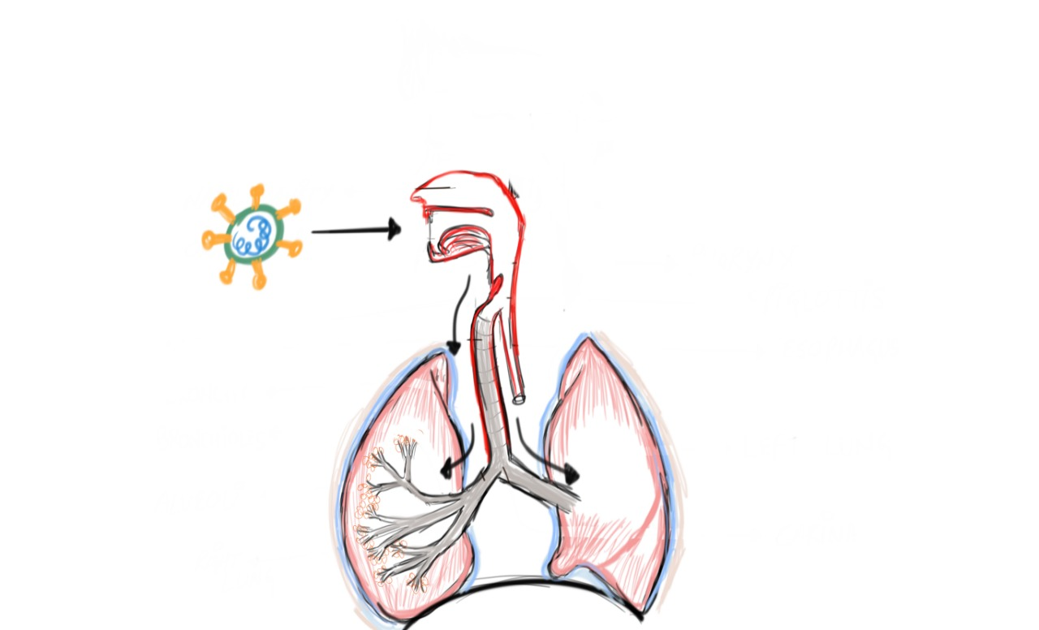

Figure 1: Coronavirus is a respiratory virus that is inhaled through the respiratory drops.

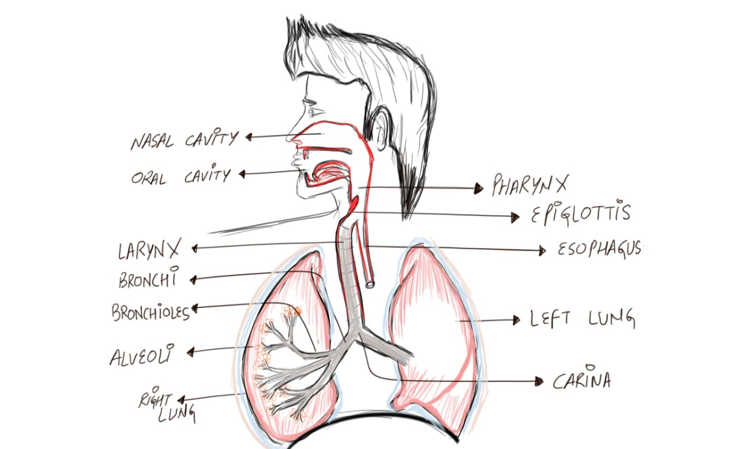

Figure: This figure shows the anatomy of the Respiratory tract of the Human body.

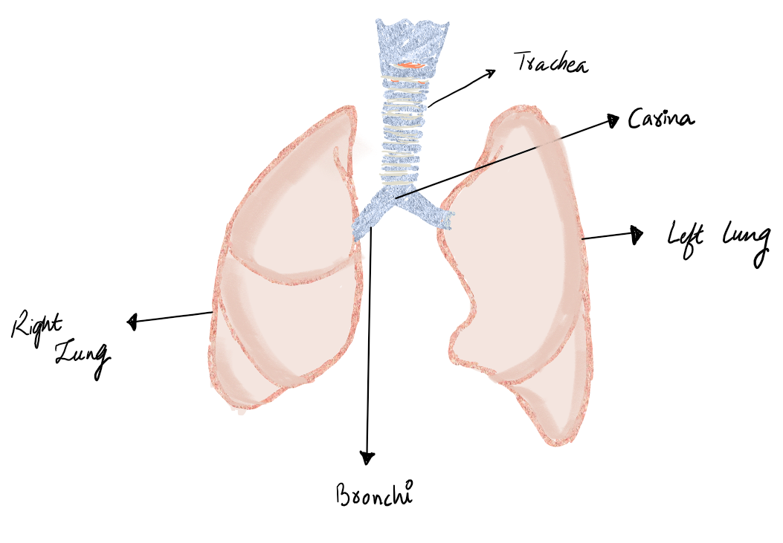

Figure: This figure shows the anatomy of the left and right lungs. Lungs are the organs that are the target of Coronavirus. Air enters through the mouth goes through the pharynx into the larynx, afterward the trachea, the trachea is followed by bronchi



Figure: This figure shows the Lobes of the Right and Left Lung. The right lung has 3 lobes whereas the left lung has 2 lobes

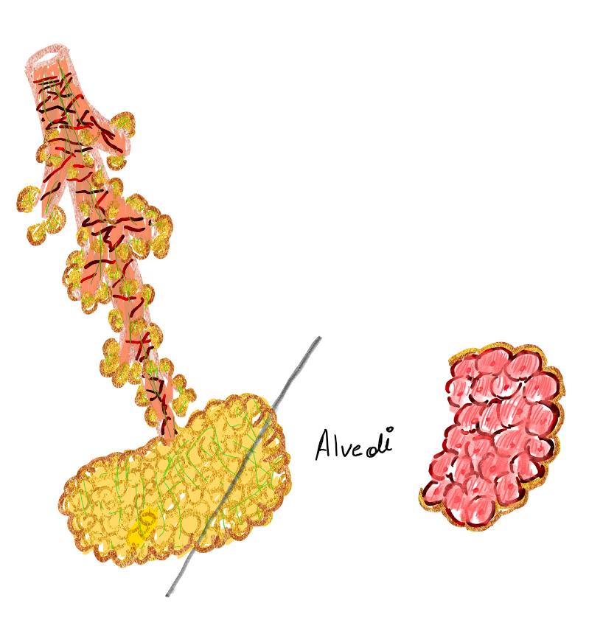

|  |  |
| --- | --- |
|  |  |
| **Figure 2: This is Alveoli, the structural unit of the lungs.**  **it is a sac-like structure, Its interior is lined by respiratory epithelium.**  **Alveoli is the part of Lungs where oxygenation of the de-oxygenated blood takes place.**  **Oxygen 02 is taken up the blood and carbon-dioxide C02 is released from the blood.** |

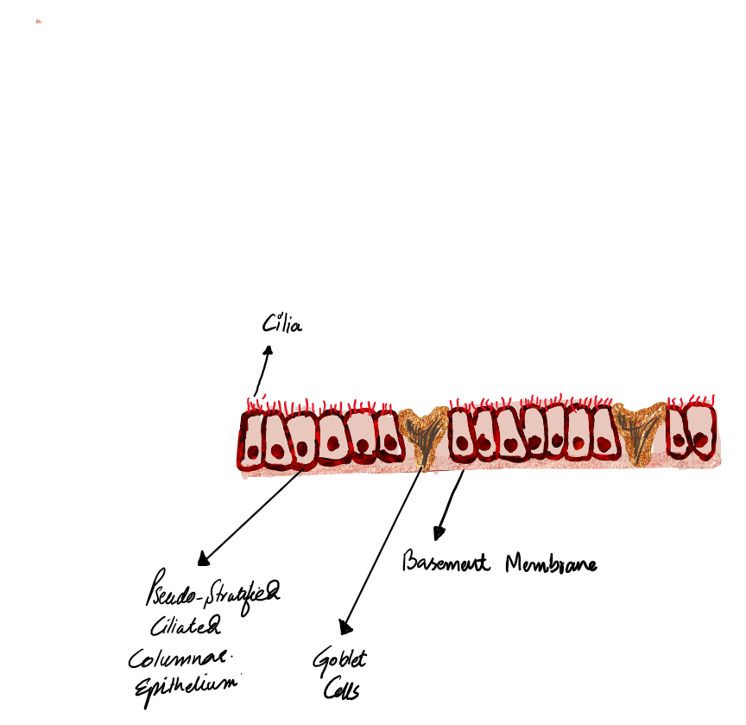

Figure 4: This shows the inner lining of the respiratory tract having respiratory epithelial cells and goblets cell. Respiratory Cells are the site of attachment of nCov-19 as they possess a special receptor known as ACE2-receptor. Spikes of the infamous virus attaches to his receptor and causes down-regulation of the function of the ACE2 enzyme.

***Basics about Viruses:***

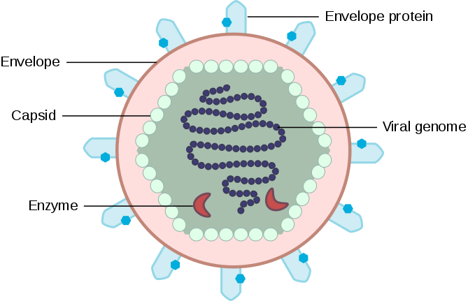

Figure 3 This image shows the structure of the Virus, [17] taken from <https://en.wikipedia.org/wiki/File:Basic_Scheme_of_Virus_en.svg>.

Viruses are particles that are having a central core that is made up of either DNA or RNA. Deoxyribonucleic acid (DNA) and Ribonucleic acid (RNA) are the nucleic acids, simply known as Genetic material of a cell.

Nucleic Acid is covered by a protein layer made up of capsomeres called Capsid,

Capsid prevents genetic material from being degraded by enzymes i-e nucleases.

Nucleocapsid is used for both Nucleic Acid and Capsid together

These viral particles have a covering made up of lipoprotein known as the envelope. On the surface of the envelope are present different kinds of protein, like Spikes in case of coronavirus.

Viruses lack the internal organelles required for cell replication(multiplication) so it needs a living cell to replicate as it will use that cell’s replicative machinery.

Diameter of viruses: 20-300nm

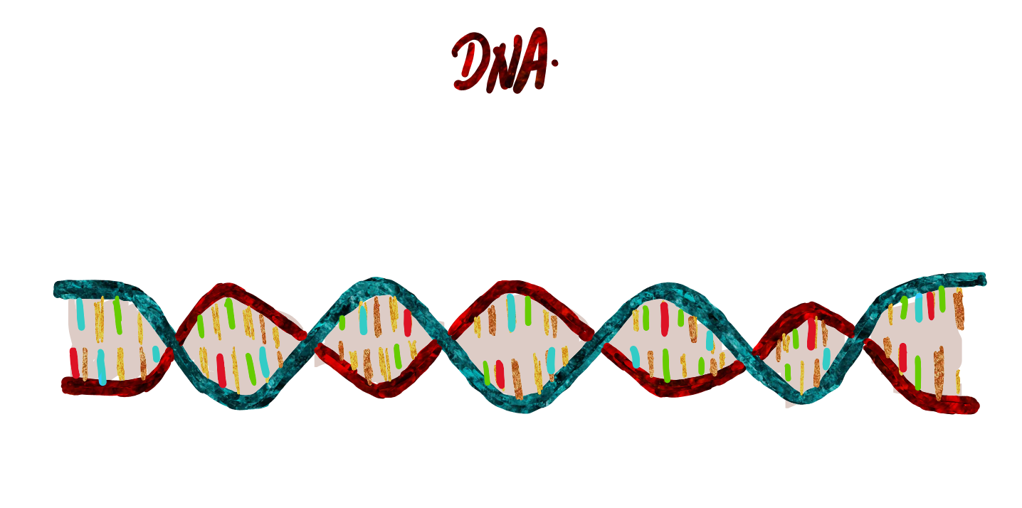

Figure 4: This shows the structure of DNA.



Figure 5: This shows the structure of RNA.

*Classification of viruses based on Genomic Material:*

Viruses are often classified according to the nucleic acid inside the capsid.

Two major classes:

1. DNA viruses
2. RNA viruses

Viruses are further divided into Enveloped or non-enveloped/naked viruses.

Nucleocapsid is the combination of Nucleic Acid and it's covering the capsid.

Nucleic Acid structure can be linear or circular.

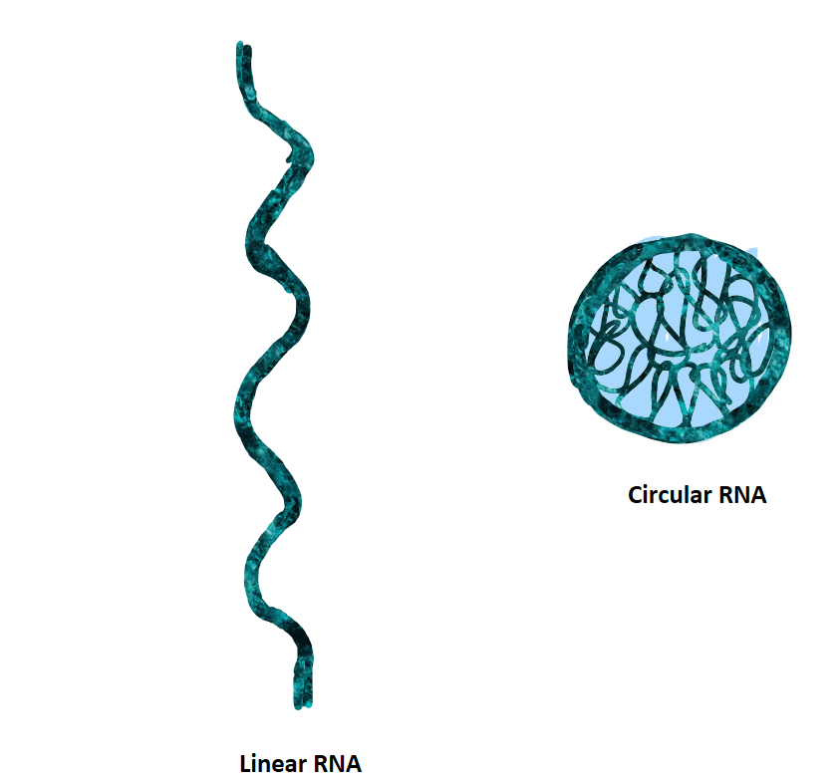

Capsid structure is two main types:

1.Icosahedral

2.Helical

Viruses having icosahedral capsid can be enveloped or non-enveloped/naked whereas viruses having helical capsid always are enveloped.

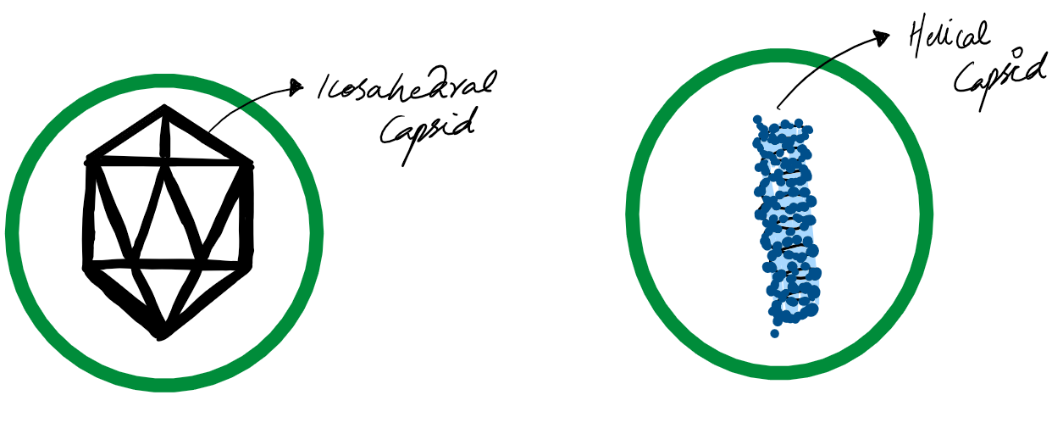

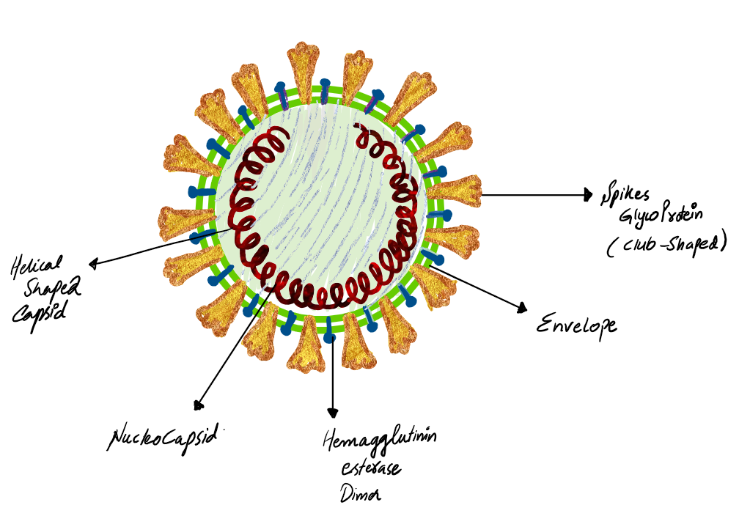

Figure: This illustration shows the structure of Coronavirus, Helical shaped capsid can be seen, on the surface of the virus are glycoprotein spikes.

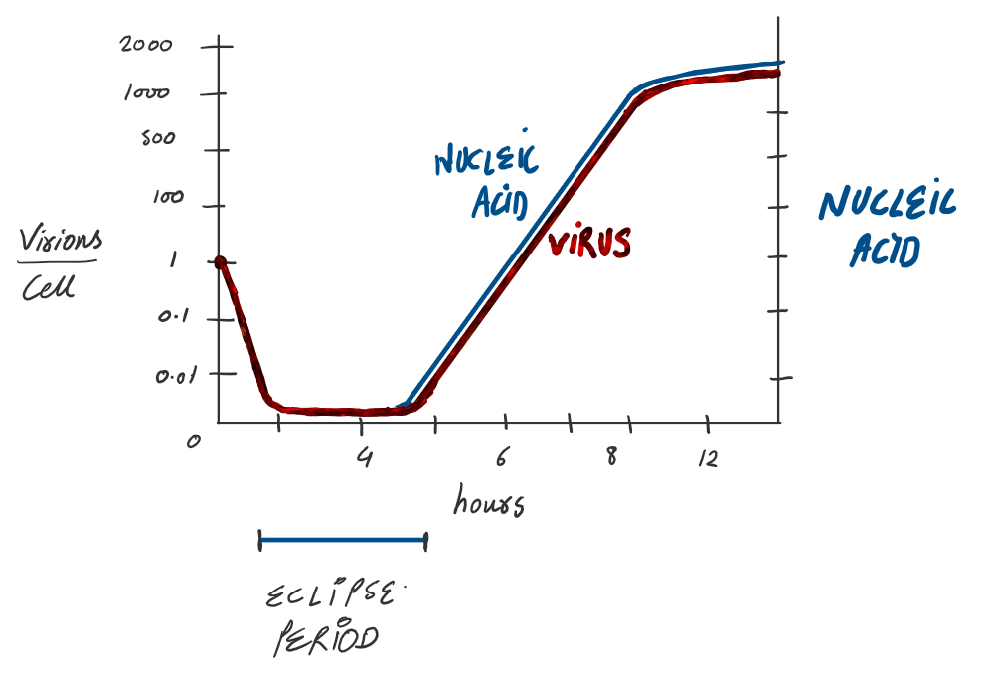

Figure: Viral Growth Curve. This graph shows the relation between time in hours, nucleic acid levels and number of virions per cell. Eclipse period is the time during which No virus is found inside the cell. [1]

**What is a mutation?**

Mutation is the change in the nucleotide sequence of the Genome of the organism, i-e virus.

Mutation can be a change in the behavior, characteristics, and properties of an organism.

Mutations in the viral genome can produce antigenic variants and drug-resistant variants.

Mutations also may produce weakened(attenuated) variants that cannot cause disease but retain their antigenicity and are useful in vaccines.

As nCov-19 is spreading it is emerging as well, Around 350 genome sequences have been uploaded on GISAID [3] as the virus is undergoing multiple mutations but at a slower rate than that of the influenza virus.

In different regions, there is a difference in the genomic sequence of the nCov. We need to be aware of it as it might be dangerous or might help in the production of Vaccine due to mutations causing weakened virions.

It accumulates on average of 1-2 mutations per month.

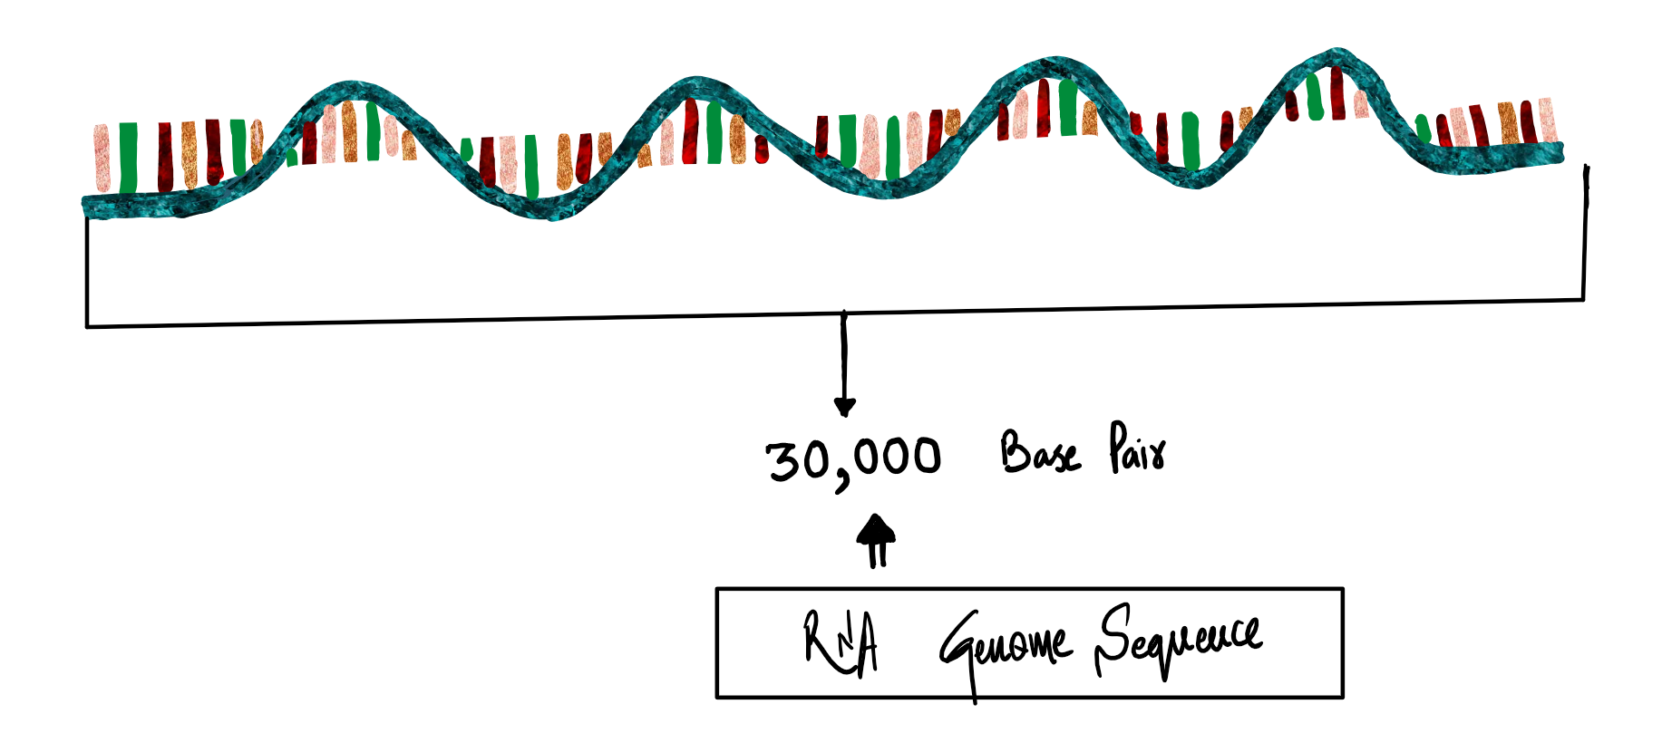

Figure: This diagram shows the RNA with a sequence of 30,000 base pairs.

Its genome (RNA)sequence has a length of about 30,000 base pairs(bp) [4].

As its undergoing Mutations, it may become more dangerous or less dangerous but no weakened virus has yet been discovered [4].

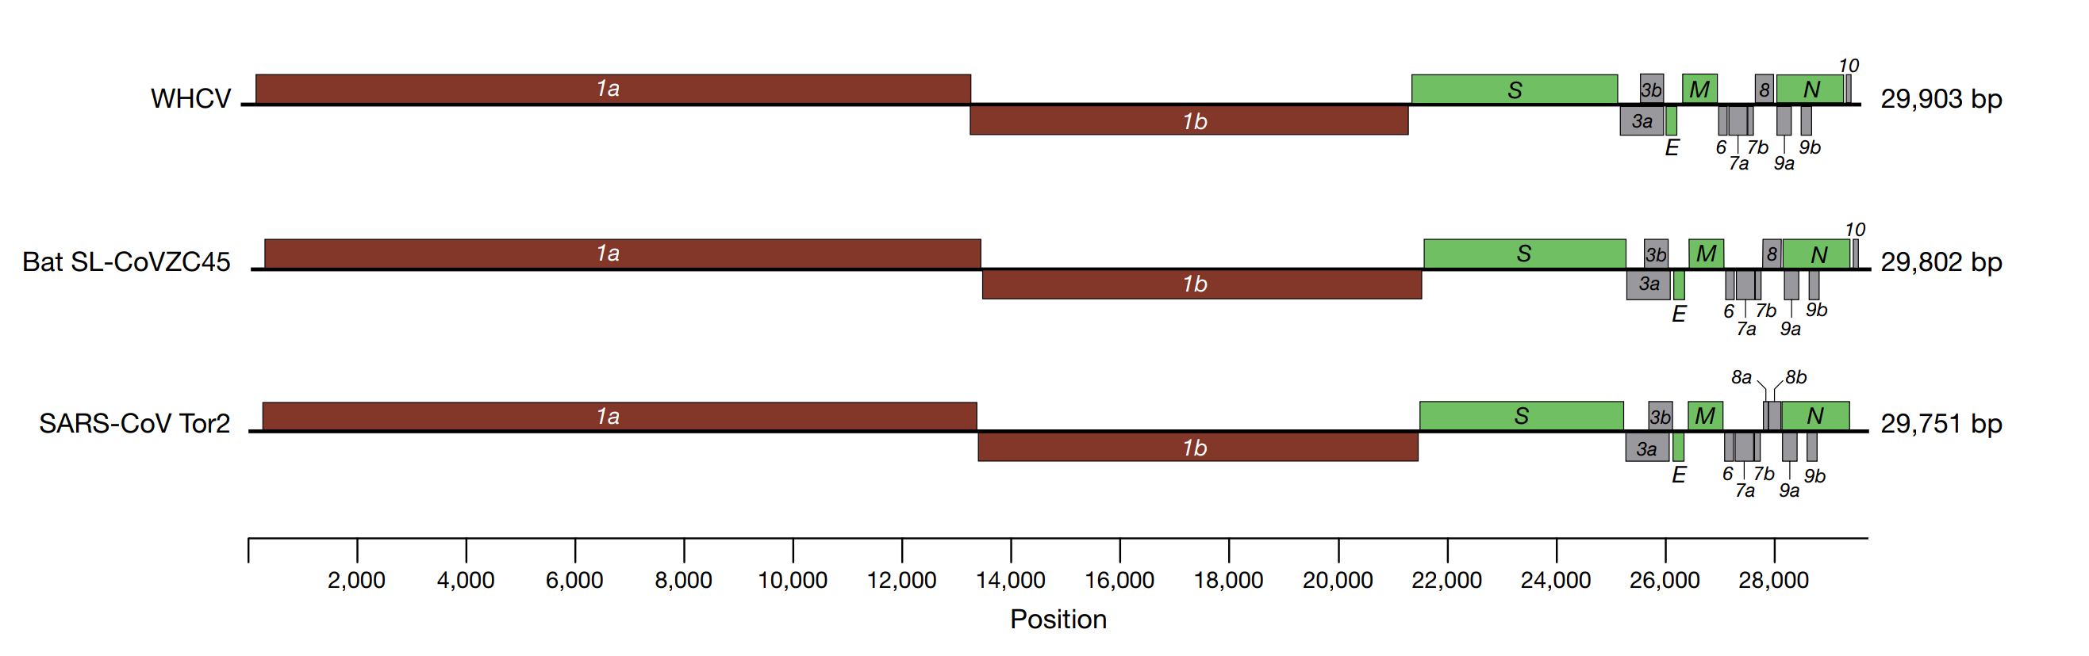

Figure Genome organization of SARS and SARS-like CoVs [5].The organization of genes for WHCV, bat SL-CoVZC45, and SARS-CoV Tor2.

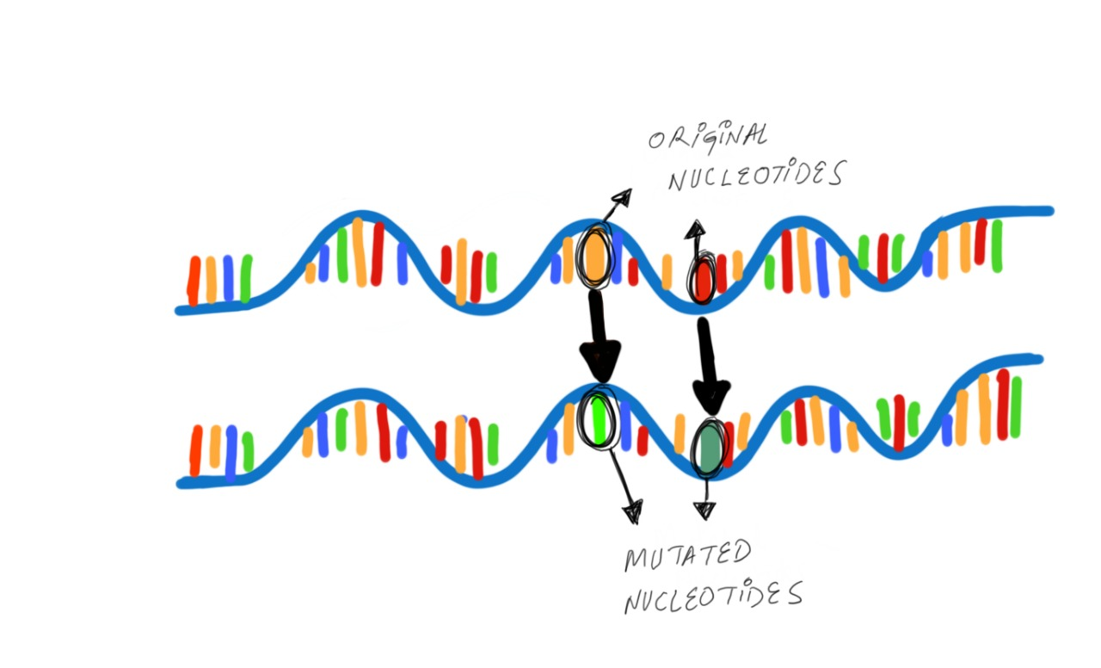

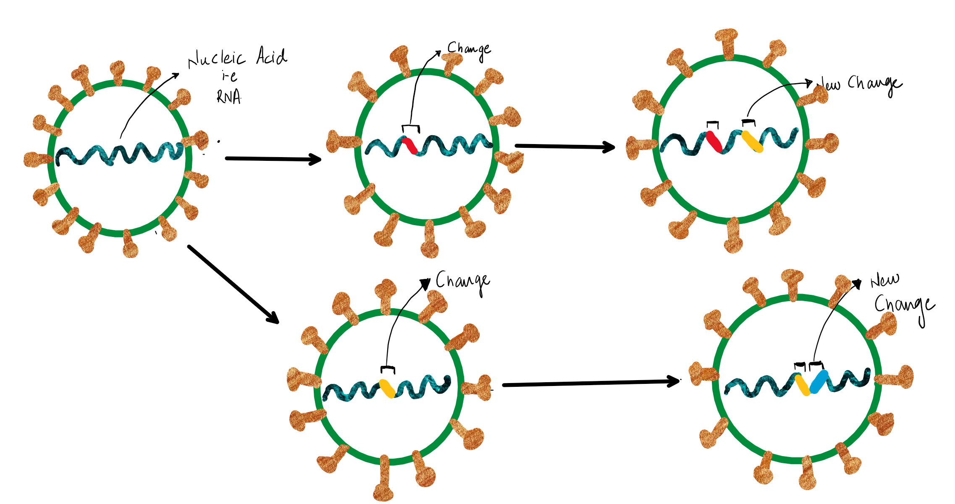  
Figure: This diagram shows how Mutations bring change in the genomic sequence of a virus. This mutation is the cause of emerging genomic sequences.

**How is Immunity produced?**

Immunity is of 3 types;

* Active Immunity is elicited by vaccines.
* Passive Immunity is elicited by the Antibodies produced in recovered human or animals.
* Herd Immunity is produced when a large population of people of the community have immunity so the remaining people are safe

The binding capacity of nCov-19 is 10-20 times more to ACE2 receptor than SARS-Cov but the antibodies against SARS-Cov were unable to bind to spikes of nCov-19 due to differences in the structure of spikes of nCov-19 so new vaccine needs to be made.

According to NIH,

“The researchers used a technique called cryo-electron microscopy to take detailed pictures of the structure of the spike protein. This involves freezing virus particles and firing a stream of high-energy electrons through the sample to create tens of thousands of images. These images are then combined to yield a detailed 3D view of the virus.” Further, they stated:

“the researchers are currently working on vaccine candidates targeting the SARS-CoV-2 spike protein. They also hope to use the spike protein to isolate antibodies from people who have recovered from infection by the new coronavirus. If produced in large quantities, such antibodies could potentially be used to treat new infections before a vaccine is available. Besides, NIH researchers are pursuing [other approaches](https://www.niaid.nih.gov/news-events/nih-clinical-trial-remdesivir-treat-covid-19-begins) to treating the virus.”

Originally published by <https://www.nih.gov/news-events/nih-research-matters/novel-coronavirus-structure-reveals-targets-vaccines-treatments>

3-D structure of the spikes was released, this spike structure will be used as a vaccine, as it when injected into the human body, will produce antibodies against the spikes that were produced in the lab, this spike will be without any infectivity (which means these spikes cant cause any kind of infection). When the antibodies against the spikes are present within the human body before the infection occurs, so when the virus invades the body, those antibodies will provide immunity against the novel coronavirus because of the similarity of the structure of the vaccine and the viral spikes [16].

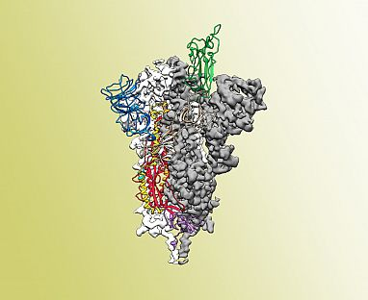

Figure: Atomic-level structure of the SARS-CoV-2 spike protein. The receptor-binding domain, the part of the spike that binds to the host cell, is colored green. UT Austin, McLellan Lab. [16]

***Coronavirus:***

Coronavirus name was coined in 1968 from Crown like appearance of the spikes of the virions under an Electron Microscope.

Before 2002 SARS-Cov, two etiological agents were known for Common Cold:

* 229E
* OC43



Diseases caused by:

* Common Cold
* SARS (Severe Acute Respiratory Syndrome) [2002]
* MERS (Middle East Respiratory Syndrome) [2012]
* COVID-19 [2019]

**SARS:**

Originated from china in November 2002.

The fatality rate was 9%.

It was transmitted from horseshoe bat to civet cat and finally Humans.

**MERS:**

Originated from Saudia Arabia and other countries in that region in 2012, MERS-CoV was identified in dromedaries in several countries in the Middle East, Africa, and South Asia.

The origins of the virus are not fully understood but, according to the analysis of different virus genomes, it is believed that it may have originated in bats and was transmitted to camels sometime in the distant past [19].

***The Novel Coronavirus***:

nCov-19 first identified in late December 2019 in Wuhan City, Hubei Province, China where patients were suffering from Pneumonia.

Now, COVID-19 is being called as Pandemic.

nCov-19 or SARS-Cov2 Important properties:

* Non-Segmented ss-RNA with positive polarity.
* Enveloped Virions with a Helical Nucleocapsid.
* Spikes attack to ACE-2 receptor.



***25 March 2020 update:***

[2]Taken from Hopkins university coronavirus map

Confirmed Cases=436,159

Deaths=19648

Countries=172

Fatality=4.50%

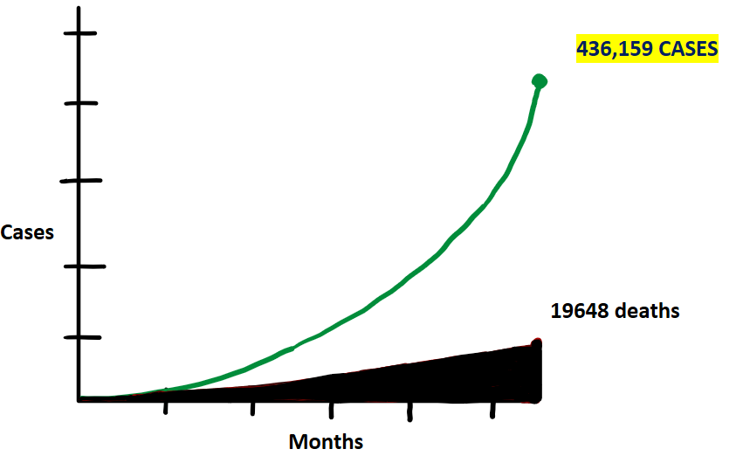

Figure: This graph shows the relationship between cases of coronavirus to the time in months.

***Charts and graphs:***

**Pie Graph showing the severity of the disease**

[13].

Figure: This pie graph demonstrates the severity of symptoms of Covid-19. A person can be asymptomatic, the patient may have mild, severe or critical disease. Most of the young without any predisposing conditions have mild symptoms.

**COVID-19 Fatality Rate by age:**

Last updated: February 29, 4:40 GMT [17]

## **COVID-19 Fatality Rate by comorbidity:**

Last updated: February 29, 4:40 GMT [17]

## **COVID-19 Fatality Rate by sex:**

Last updated: February 29, 4:40 GMT [17]

***Transmission:***

Spreading by Respiratory droplets i-e aerosols through;

* Person to Person Transmission by Coughing, sneezing or speaking.
* Contaminated surfaces.

Exact Etiology is not known but bats, snakes or raccoons may be the cause.

It is transmissible up to distance of 1meter or 3 feet.

It can live up to 2 days on the surfaces.

***High-Risk Cases:***

* Elderly
* Hypertensive
* Smokers
* Cardio-vascular disease
* Diabetes mellitus
* Chronic respiratory disease
* Immune deficient
* Cancer

“The much-discussed hope that warmer, more humid weather will strangle the Covid-19 pandemic may or may not pan out, but there are solid data that it will make a difference to any aerosol transmission. The SARS virus survived better at 30% to 50% relative humidity than at 80%, with a half-life of only three hours rather than 27 hours at 30% humidity. Other research has also found that coronaviruses have much more difficulty existing in aerosol form in warm, humid conditions.”Editor's note: The study described in this article was [published in The New England Journal of Medicine](https://www.nejm.org/doi/10.1056/NEJMc2004973) on March 17. This article was originally published on March 13.

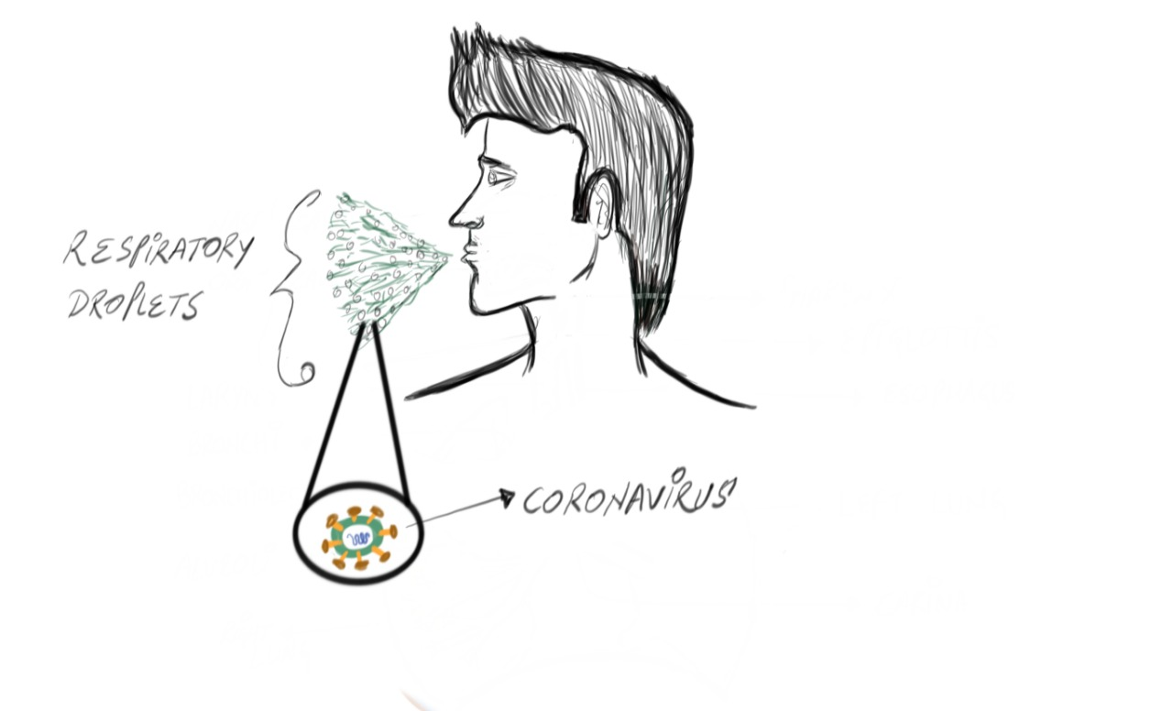

***Pathophysiology:*** *(Note! For Medical care officials)*

Human Respiratory epithelial cells are the site attacked by the SARS-Cov2.

As We inhale the respiratory droplets containing coronavirus, it goes through the respiratory tract and reaches up to the level of alveoli the main structural and functional unit of lungs.

nCov-19 spikes bind to the Human respiratory cell surface ACE-2 (angiotensin-converting enzyme-2) receptor just like SARS-Cov of 2002 [11].

Binding capacity of nCov-19 is 10-20 times more to ACE2 receptor than SARS-Cov.

ACE-2 enzyme has a protective mechanism against acute lung injuries as it regulates the level of angiotensin II.

nCov-19 when infects the respiratory epithelium, Pro-Inflammatory mediators are released which causes the inflammatory response which causes the symptoms.

Inflammatory mediators (Interleukins, G-CSF, MIP-1 alpha, MCP-1, INF-gamma-IP) that may be involved.

Binding of nCov-19 to the receptor causes down-regulation of the enzyme Angiotensin-converting enzyme-2 which degrades angiotensin I and angiotensin II. The degradation product is angiotensin.

When the ACE2 is inactivated by the coronavirus, there is no check and balance for angiotensin II formation and it goes unchecked and its level increases a lot.

High Levels of Angiotensin II binds to angiotensin II receptor type 1a (AGTR1A) and causes its over-stimulation.

Over-stimulation of AGTR1A results in dysregulation of the fluid balance across the alveolar space and the respiratory epithelium.

Excess Accumulation of fluid occurs which results in Alveolar edema can produce hazardous effects.

Alveolar edema prevents proper oxygenation of the de-oxygenated blood coming to the lungs for oxygenation.

Decreased oxygen levels in the blood is called hypoxia, which predisposes the ill to the use of oxygen therapy to increase the O2 saturation level to meet the demands of the human body.

As the disease progresses it leads to Acute Respiratory distress syndrome.

When the mediators are released into circulation, they cause diffuse inflammatory reactions in the body which ends into septic shock.

Septic shock decreases the blood flow to organs leading into Multiple organ failure (MOF) and finally Death!

|  |  |  |  |
| --- | --- | --- | --- |
|  |  |  |  |
|  |  |  | **Figure: This is an illustration showing the infective and Replicative cycle of Coronavirus.**  **First of all, nCov-19 is inhaled into the Lungs as they are suspended into the respiratory droplets.**  **The nCov-19 binds to the receptors present on the surface of respiratory epithelium,**  **They downregulate the ACE2 receptor and penetrate the respiratory cells, within the respiratory cells,**  **They un-coat themselves to release the genomic material that is RNA of the virion.**  **This RNA of the virus with the help of the replicative machinery of the respiratory cell form new RNA and viral proteins.**  **These new RNAs and viral proteins are used to assemble new viruses that are then released by exocytosis.**  **New virions infect the remaining respiratory epithelial cells.** |
|  |  |  |  |
|  |  |  |  |
|  |  |  |  |
|  |  |  |  |
|  |  |  |

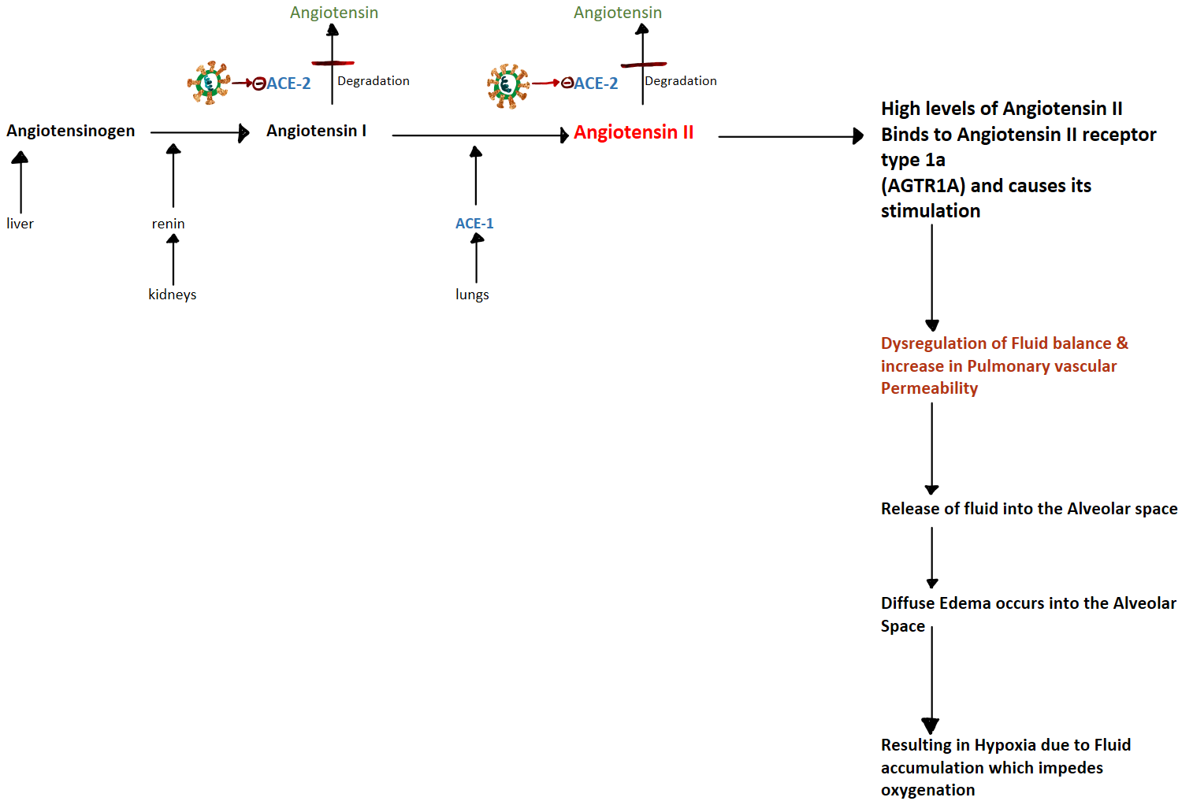

Figure: This figure demonstrates the action of angiotensin II and ACE2 enzyme. The liver produces angiotensinogen which is converted to angiotensin I by the action of renin released from kidneys when the GFR is decreased due to decreased blood pressure or any other cause. Angiotensin I is converted to Angiotensin II by the action of Angiotensin-converting enzyme-1 (ACE1) released from the lungs, Angiotensin-converting enzyme-2 (ACE2) is the enzyme which degrades angiotensin I and angiotensin II to inactive forms of angiotensin preventing over-stimulation of AGTR1A receptor. Increased levels of Angiotensin II cause the over-stimulation of Angiotensin II receptor type 1 A (AGTR1A), Over-stimulation of AFTR1A leads to dysregulation of fluid balance across the membranes of respiratory epithelium, this leads to Accumulation of fluid in the alveolar space. Alveolar space edema impedes the proper oxygenation of the blood.

**Process in production of new Virions:**

-Adsorption (fusion of spikes to the human cell surface)

-Penetration (endocytosis)

-Uncoating (uncovers to remove genome into cytoplasm of the human cell)

-Viral Nucleic Acid undergoes 3 processes within the Human Cell

1.Transcription

2.Translation

3.Replication

-exocytosis (release of virions from the human cell)

-New virions Infect other cells

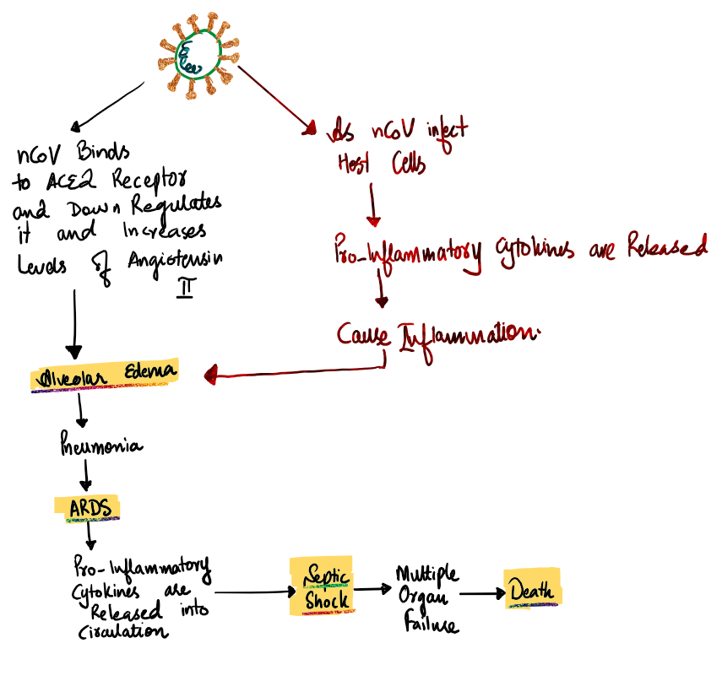

Figure: This shows how the nCov-19 causes ARD, septic shock and death

***Acute respiratory distress syndrome (ARDS):***

Acute respiratory distress syndrome (ARDS) can occur in critically ill persons with underlying illnesses. It causes severe build-up of fluid inside the lungs, that prevents the proper functioning of lungs i-e gaseous exchange.

Gaseous exchange is the removal of carbon-dioxide and take-up of oxygen.

How does ARDS occur?

Acute respiratory distress syndrome can be caused by direct or indirect injuries to the lungs.

ARDS occurs when the virus has caused enough damage so the body tries to prevent further damage to the lungs, releases mediators and bring in inflammatory cells to the site of infection. Acute respiratory distress syndrome is more related to the body’s response rather than the damage by the virus itself [20].

In Acute respiratory distress syndrome, capillaries are damaged leading to leakage of fluid into the alveoli, this build-up of fluid impairs gaseous exchange. It progresses rapidly and can lead to scarring which makes it even harder for the lungs to perform their function [21].

ARDS causes rapid progressive shortness of breath.

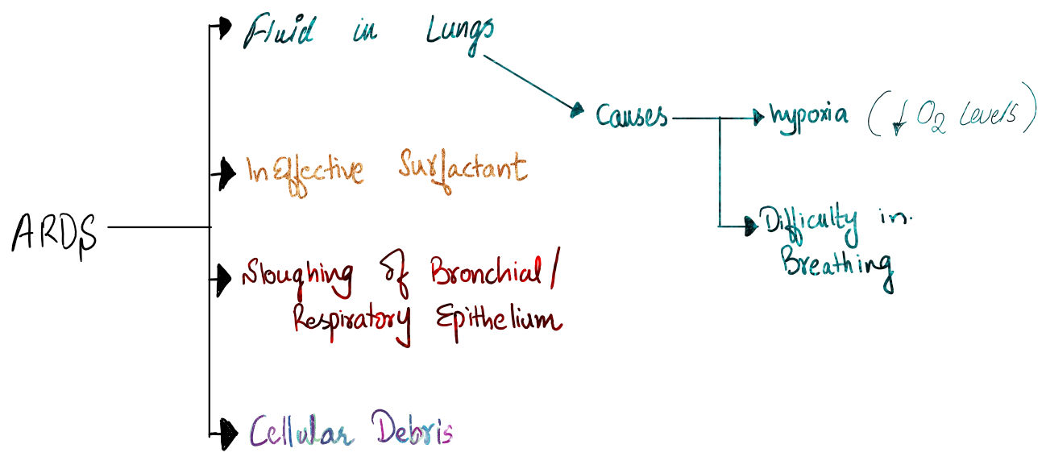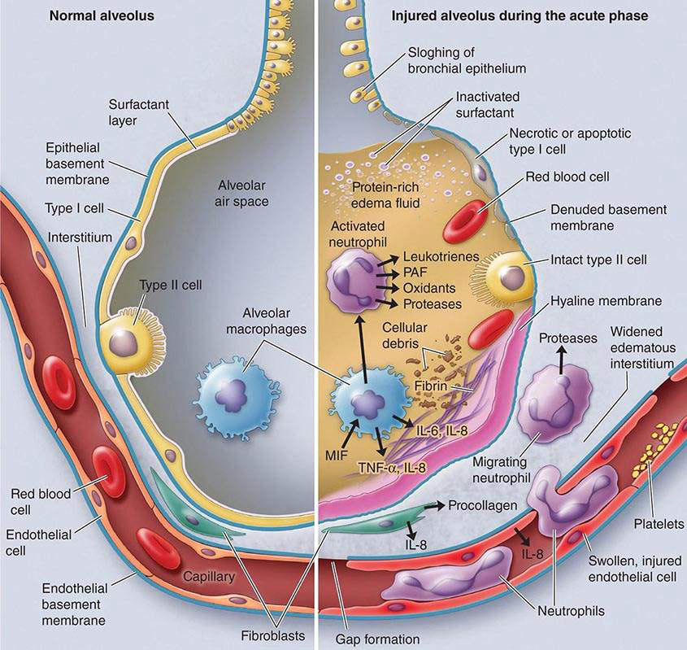

Figure: A normal alveolus (left) and a damaged injured alveolus in the acute phase of acute respiratory distress syndrome (right). This figure is taken from <https://www.daviddarling.info/encyclopedia/A/acute_respiratory_distress_syndrome.html>

***Clinical Features:***

Incubation Period: 2-14 days [11].

The incubation period is the time between Entry or exposure of the pathogen and the development of signs and symptoms.

Symptoms caused by the COVID-19 can range from mild to severe

According to the WHO, the most common symptoms of Covid-19 are fever, tiredness and a dry cough.

Shortness of breath is a common symptom in the case of COIVD-19 but is not present in case of the common cold. Shortness of breath is also a common feature in case of allergies.

Some clinical features are quoted here;

* Fever [99%]
* Fatigue [70%]
* Dry cough [59%]
* Muscular/ body aches [35%]
* Shortness of breath [31%]
* Sputum production [27%]
* Sore throat
* Headaches
* lethargy
* Bluish tongue or lips
* Chest pain
* Pneumonia
* Nausea/ diarrhea
* ARDS (acute respiratory distress syndrome)
* Septic Shock

*Warning Signs:*

* Persistent Chest pain or pressure
* Confusion
* Difficulty in breathing
* Bluish lips or tongue

***Day-to-Day Features may vary:***

[9] [10]

**Around Day-1 to Day-4:**

* Fever is the Main Symptom [ temperature of 100F or 37.7C]
* Fatigue
* Lethargy
* Dry cough
* Sore throat
* Muscle aches
* Nausea
* Diarrhea
* Headache

**Around Day-5:**

* Difficulty in breathing is the main symptom
* Other symptoms

**Around Day-8:**

* Some feel better
* Some worsen ARDS

**Around Day-15:**

* People recover
* Others worsen further

# ***Diagnosis:***

* Clinical
* Laboratory testing
* Radiology
* rRT-PCR

***Laboratory Findings:***

[11]

* leukopenia or leukocytosis
* lymphopenia
* increased Lactate dehydrogenase (LDH) levels
* Inflammatory Response Mediators Detection

-CRP

-Procalcitonin

-Interleukins IL-4, IL-6, and IL-10

-TNF-alpha

-Interferon-gamma

* increased Ferritin levels
* increased Aminotransferase levels

***Radiological Findings:***

*Chest X-Ray (CXR):*

A chest X-ray may show subpleural peripheral opacities.

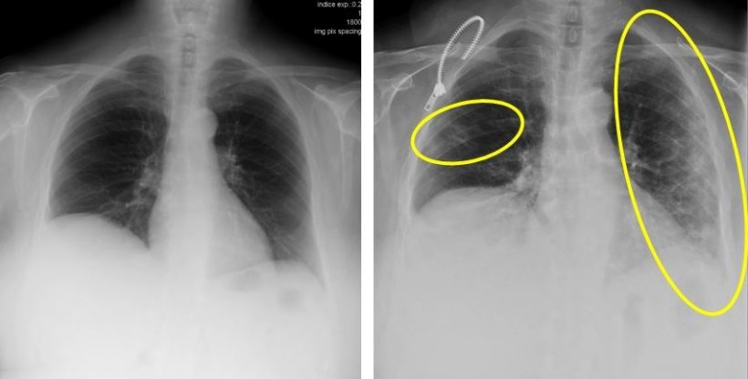

Figure: These two X-ray images are from a 72-year-old woman who has a cough and respiratory distress from last year (left) and now. The yellow circle and ovoid indicate the typical subpleural peripheral opacities, originally published on <https://healthcare-in-europe.com/en/news/imaging-the-coronavirus-disease-covid-19.html> [14].

### *Chest CT-Scan:*

[11][15].

Most common Picture on CT-scan

“Multiple, patchy, peripheral, bilateral, lower lobes Areas of Ground-Glass Appearance.”

As the disease progresses, the consolidation increases and involves a complete lung called “White Lung.”

Features that may be present of Chest CT:

* Bilateral involvement
* Patchy
* Peripheral
* Lower lobes
* Ground-glass opacities
* Vascular thickenings
* Fine reticular opacities
* Less common features:

-Pleural thickening

-Pleural effusion

-lymphadenopathy

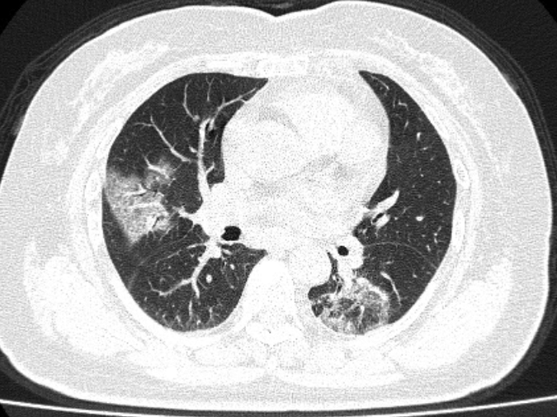

Figure A: A 79-year-old woman who presented with fever, dry cough, and chest pain for 3 days. Her husband and daughter-in-law had been recently diagnosed with coronavirus disease 2019 (COVID-19), Axial (A) and coronal (B) CT images show multiple patchy, peripheral, bilateral areas of ground-glass opacity. The patient expired 11 days after admission (Courtesy of Song F, Shanghai. *Citation: American Journal of Roentgenology: 1-5. 10.2214/AJR.20.22969.* Read More: <https://www.ajronline.org/doi/full/10.2214/AJR.20.22969>

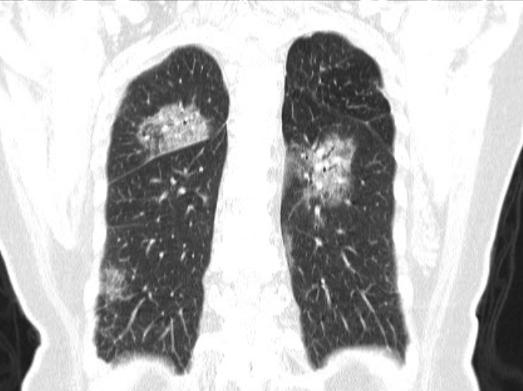

Figure B: 79-year-old woman who presented with fever, dry cough, and chest pain for 3 days. Her husband and daughter-in-law had been recently diagnosed with coronavirus disease 2019 (COVID-19) B, Axial (A) and coronal (B) CT images show multiple patchy, peripheral, bilateral areas of ground-glass opacity. Patient expired 11 days after admission (Courtesy of Song F, Shanghai

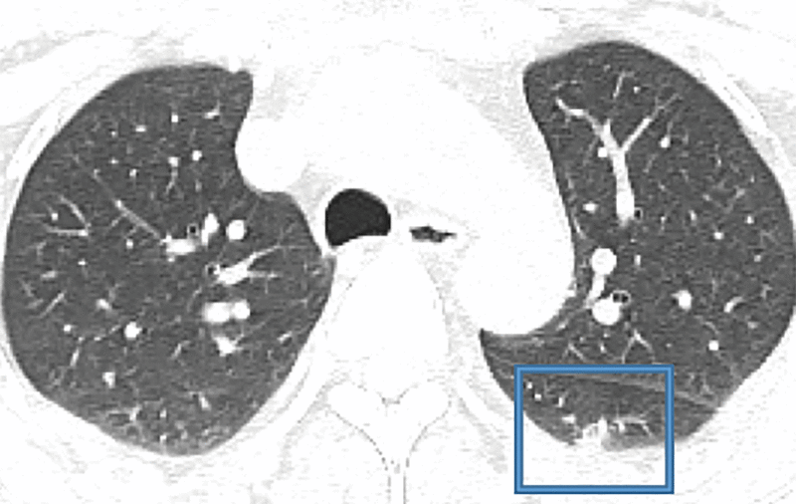

Figure A: 47-year-old Chinese man with a 2-day history of fever, chills, productive cough, sneezing, and fatigue who presented to the emergency department. (Courtesy of Liu M, China-Japan Friendship Hospital, Beijing, China). Initial CT images obtained show small round areas of mixed ground-glass opacity and consolidation (*rectangles*) at the level of the aortic arch (A) and ventricles (B) in right and left lower lobe posterior zones.

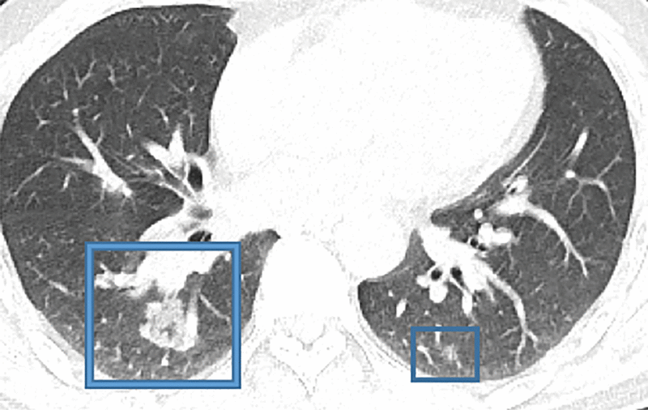

Figure B: 47-year-old Chinese man with a 2-day history of fever, chills, productive cough, sneezing, and fatigue who presented to the emergency department. (Courtesy of Liu M, China-Japan Friendship Hospital, Beijing, China). Initial CT images obtained show small round areas of mixed ground-glass opacity and consolidation (*rectangles*) at the level of the aortic arch (A) and ventricles (B) in right and left lower lobe posterior zones.

***rRT-PCR:***

Real-time Reverse transcription Polymerase Chain Reaction is the method for detection of SARS-Cov2 genome, it’s a quick method for detection of the RNA sequence of the virion.

The CDC 2019-nCoV Real-Time RT-PCR Diagnostic Panel contains the following: taken from <https://www.cdc.gov/coronavirus/2019-ncov/lab/tool-virus-requests.html>

* 2019-nCoV_N1, 2019-nCoV_N2 and 2019-nCoV_N3 primers and probes that target the nucleocapsid (N) gene and are designed for both universal detection of SARS-like coronavirus as well as specific detection of the 2019-nCoV;
* RP primers and probes that target the Human RNase P gene; and
* nCoVPC, the 2019-nCoV positive control used in the assay.

|  |  |  |  |
| --- | --- | --- | --- |
|  |  |  |  |
|  |  |  |  |
|  |  |  |

***Other Techniques:***

* *Virus Isolation and Culture:*

Samples from patients sputum, feces, etc are implanted on Vero-E6 cells medium for culture.

* *Detection of Serum Antibody:*

IgM antibody is detected almost 10 days after symptoms.

IgG antibody is detected almost 12 days after symptoms.

Positive Serum-Specific IgM or specific IgG antibody titer in the recovery phase > 4 times than that of the Acute phase, can be of diagnostic criteria for suspected patients with negative nucleic acid detection [22].



* *Bronchoscopy:*

can be used for:

* To get samples of SARS-cov2 or other pathogens for laboratory tests.
* To visualize the airway.
* To administer the medications like interferons.
* To assist in the establishment of artificial airway [22].

The diagnostic criteria follow the Protocol for the Diagnosis and Treatment of CDVID-2019. A confirmed case is based on epidemiological history (including cluster transmission), clinical manifestations (fever and respiratory symptoms), lung imaging, and results of SARS-CoV-2 nucleic acid detection and serum-specific antibodies. Taken from Handbook of COVIO-19 Prevention and Treatment- First Affiliated Hospital, Zhejiang University School of Medicine (FAHZU) [22].

**Clinical Classifications**:

Taken from Handbook of COVID-19 Prevention and Treatment- First Affiliated Hospital, Zhejiang University School of Medicine (FAHZU) [20].

* Mild Cases:

The clinical symptoms are mild and no pneumonia manifestations can be found in imaging.

* Moderate Cases

Patients have symptoms such as fever and respiratory tract symptoms, etc. and pneumonia manifestations can be seen in imaging.

* Severe Cases:
* Adults who meet any of the following criteria:

-respiratory rate equal to or more than 30 breaths/min;

-oxygen saturation equal to or less than 93% at a rest state;

-arterial partial pressure of oxygen (PaO2)/oxygen concentration (FiO2) equal to or less than 300 mm Hg.

-Patients with > 50% lesions progression within 24 to 48 hours in lung imaging.

* Critical Cases Meeting any of the following criteria:

-occurrence of respiratory failure requiring mechanical ventilation

-presence of shock

-other organ failures that require monitoring and treatment in the ICU.

***Treatment:***

*(Note! For Medical care officials only, don’t use without a prescription)*

Taken from Handbook of COVID-19 Prevention and Treatment- First Affiliated Hospital, Zhejiang University School of Medicine (FAHZU) [22].

No definitive treatment is available for Novel coronavirus, all we can do is to provide supportive care.

***Self-Care:***

Rest and sleep

Drink plenty of warm fluids

Keep warm

Use antipyretics

Self-isolate to protect others

In the case of Warning Signs, Seek medical care.

*Important drugs:*

* Lopinavir/ritonavir
* Interferon
* Remdesivir.
* Chloroquine
* Hydroxychloroquine
* Fapilavir
* Tocilizumab
* darunavir/cobicistat
* *Fluid Management* and strict control to prevent excess fluid burden.
* *Proper Monitoring* of the patients, symptoms and laboratory tests.
* *Nutritional support:*

Oral feeding is preferred, but if not possible, we can use enteral feeding.

* *Prevention of Aspiration:*
* *Antiviral therapy* Taken from Handbook of COVID-19 Prevention and Treatment- First Affiliated Hospital, Zhejiang University School of Medicine (FAHZU) [22].

-lopinavir/ritonavir (2 capsules, PO q12h) combined with arbidol (200mg PO q12h) was applied as the basic regimen.

-Favipiravir (starting dose of 1600mg followed by 600mg TID) is an alternative to Lopinavir/Ritonavir.

-Chloroquine phosphate or hydroxychloroquine (500mg BD for 1-2days followed by 500mg QD for following 5days), The treatment course of chloroquine phosphate should be no more than 7 days.

-Interferon Nebulization or spray.

* *Use of Corticosteroids:*

To prevent disease progression and cytokine cascade. Initial routine methylprednisolone at a dose of 0.75-1.5 mg/kg intravenously once a day (nearly 40 mg once or twice a day) is recommended.

* *Oxygen therapy:*

Oxygen therapy prevents secondary organ damage caused by respiratory distress and hypoxemia. Continuous monitoring of oxygen saturation is required before, during and after oxygen therapy.

The treatment goal of oxygen therapy is to maintain the oxygen saturation {SpO2) at 93%-96% for patients without chronic pulmonary disease and at 88%-92% for patients with chronic type II respiratory failure.

PaO2/FiO2 is a sensitive and accurate indicator of oxygenation function.

* *Mechanical Ventilation:*

Noninvasive Ventilation (NIV): A short-term (less than 2 hours) use of NIV can be closely monitored if the patient has acute left heart failure, chronic obstructive pulmonary disease or is immunocompromised.

Invasive Mechanical Ventilation: We need to balance the ventilation and oxygenation; we can set the tidal volume at 4-8 mL/kg. Maintain the platform pressure< 30 cm of water and driving pressure <15 cm of water. Ventilation frequency: 18-25 times per minute.

* *Antibiotics in case of bacterial super-infection:*

Antibiotics include quinolones, the second or third-generation cephalosporins, beta-lactamase inhibitor compounds, etc.

The antibiotics should be used for the prevention of bacterial infection in critically severe patients, especially those with invasive mechanical ventilation.

The antibiotics such as carbapenems, beta-lactamase inhibitor compounds, linezolid, and vancomycin can be used in critically ill patients according to the individual risk factors.

* *Use of antipyretics (NSAIDs or acetaminophen*
* *Identification of adverse drug effects and drug interactions.*
* *Special attention should to made for pregnant, patients with renal and hepatic insufficiency.*
* *Psychological support for the patients.*

**Discharge standards**

Taken from Handbook of COVID-19 Prevention and Treatment- First Affiliated Hospital, Zhejiang University School of Medicine (FAHZU) [22].

* Body temperature remains normal for at least 3 days (ear temperature is lower than 37.5 °C);
* Respiratory symptoms are significantly improved;
* The nucleic acid is tested negative for respiratory tract pathogen twice consecutively (sampling interval more than 24 hours); the nucleic acid test of stool samples can be performed at the same time if possible;
* Lung imaging shows obvious improvement in lesions;
* There is no comorbidities or complications which require hospitalization;
* SpO2 > 93% without assisted oxygen inhalation;
* Discharge approved by multi-disciplinary medical team



***Prevention:***

[4] [6]

Active Immunity has not yet been made.

Passive Immunity can be made with the help of plasma from the recovered patients.

**Community Exposure prevention:**

* Personal hygiene is necessary.
* Hand washing often.

Watch tutorials on how to clean your hands properly and wash for at least 20-30seconds.

* Respiratory hygiene (covering from sneeze or cough by elbow or tissue).
* Avoid close contact.
* Avoid touching the face (eyes, nose or mouth).
* Mask is not recommended in the community.
* Stay at home.
* Avoid public places
* Avoid unnecessary outing.
* Use Alcohol-based sanitizers.
* Maintain a distance of at least 1-2meters from a person coughing or sneezing [8].
* Clean and disinfect frequently touched surfaces and objects, such as doorknobs [23].
* Stayed tuned for new information about the coronavirus.
* In case of symptoms stay at home, self-quarantine and call for medical assistance.
* Wear a face mask if you are sick or going into close contact.
* Avoid having visitors.
* Properly cook food.
* Limit contact with predisposed individuals.
* Avoid personal contact, such as kissing, or sharing cups or eating utensils, with sick people [23].
* Boost your immune system by proper diet, fluid intake, and exercise.
* Increase intake of vitamin-C containing food items.

Health Care Worker Protection & Use of PPE (personal protective equipment):

* Use of Masks, Disposable latex gloves, and Disposable surgical caps.
* Use of goggles.
* Medical protective mask (N95)
* Work uniform or protective clothing.
* Disinfect the Floor and Walls of wards with 1g/L chlorine-containing disinfectants.
* Disinfect and sterilize instruments and equipment like endoscope and bronchoscope.
* Face shield/ Powered Air Purifying respirator.
* Disinfect and purify the air of the wards.
* Proper disposal of fecal matter and sewage.
* All of the healthcare staff must wear medical surgical masks



**Disinfect Surfaces**

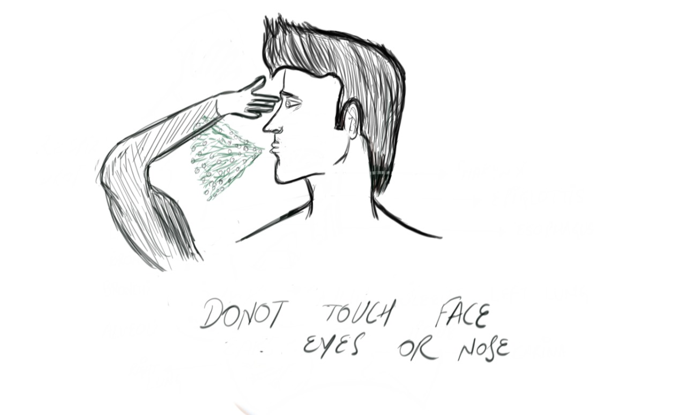

Don’t touch face, eyes or nose.

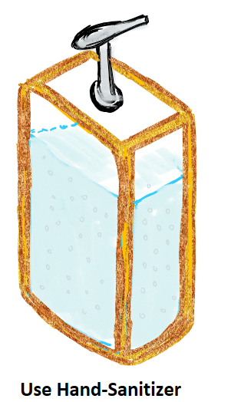

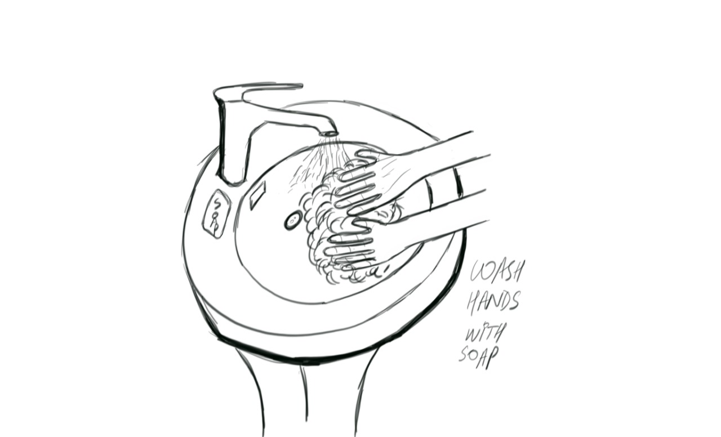

wash hands with soap often

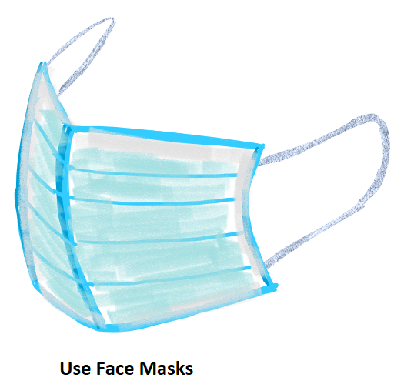



Cover your face with tissue or sleeves while sneezing or coughing.

# **Bibliography**

|  |  |
| --- | --- |
| [1] | M. Warren Levinson, Review of Medical microbiology and immunology, fourteenth edition. |
| [2] | [Online]. Available: https://coronavirus.jhu.edu/map.html. |
| [3] | [Online]. Available: https://www.gisaid.org/. |
| [4] | [Online]. Available: https://www.sciencemag.org/news/2020/03/mutations-can-reveal-how-coronavirus-moves-they-re-easy-overinterpret. |
| [5] | [Online]. Available: https://www.statnews.com/2020/03/16/coronavirus-can-become-aerosol-doesnt-mean-doomed/. |
| [6] | [Online]. Available: https://www.cdc.gov/coronavirus/2019-ncov/prepare/prevention.html. |
| [7] | [Online]. Available: https://www.nature.com/articles/s41586-020-2008-3/figures/1. |
| [8] | [Online]. Available: https://www.who.int/emergencies/diseases/novel-coronavirus-2019/advice-for-public. |
| [9] | [Online]. Available: https://www.mirror.co.uk/news/us-news/woman-shares-reality-coronavirus-fight-21719249. |
| [10] | [Online]. Available: https://www.businessinsider.com/coronavirus-covid19-day-by-day-symptoms-patients-2020-2. |
| [11] | [Online]. Available: https://www.uptodate.com/contents/coronavirus-disease-2019-covid-19. |
| [12] | [Online]. Available: https://www.worldometers.info/coronavirus/coronavirus-age-sex-demographics/. |
| [13] | [Online]. Available: https://www.nih.gov/news-events/nih-research-matters/novel-coronavirus-structure-reveals-targets-vaccines-treatments. |
| [14] | [Online]. Available: https://healthcare-in-europe.com/en/news/imaging-the-coronavirus-disease-covid-19.html. |
| [15] | [Online]. Available: https://www.ajronline.org/doi/full/10.2214/AJR.20.22969. |
| [16] | [Online]. Available: https://www.nih.gov/news-events/nih-research-matters/novel-coronavirus-structure-reveals-targets-vaccines-treatments. |
| [17] | [Online]. Available: https://www.worldometers.info/coronavirus/coronavirus-age-sex-demographics/. |
| [18] | [Online]. Available: https://en.wikipedia.org/wiki/File:Basic_Scheme_of_Virus_en.svg. |
| [19] | [Online]. Available: https://www.who.int/news-room/fact-sheets/detail/middle-east-respiratory-syndrome-coronavirus-(mers-cov). |
| [20] | [Online]. Available: https://www.health.com/condition/infectious-diseases/coronavirus/what-is-ards. |
| [21] | [Online]. Available: https://www.daviddarling.info/encyclopedia/A/acute_respiratory_distress_syndrome.html. |
| [22] | P. T. LIANG and C. Y. C. Z. F. Q. H. W. I. H. S. L. CAI Hongliu, in *HandbookofCOVI0-19 Prevention and Treatment*. |
| [23] | [Online]. Available: https://www.cdc.gov/coronavirus/mers/about/prevention.html. |